For immediate release

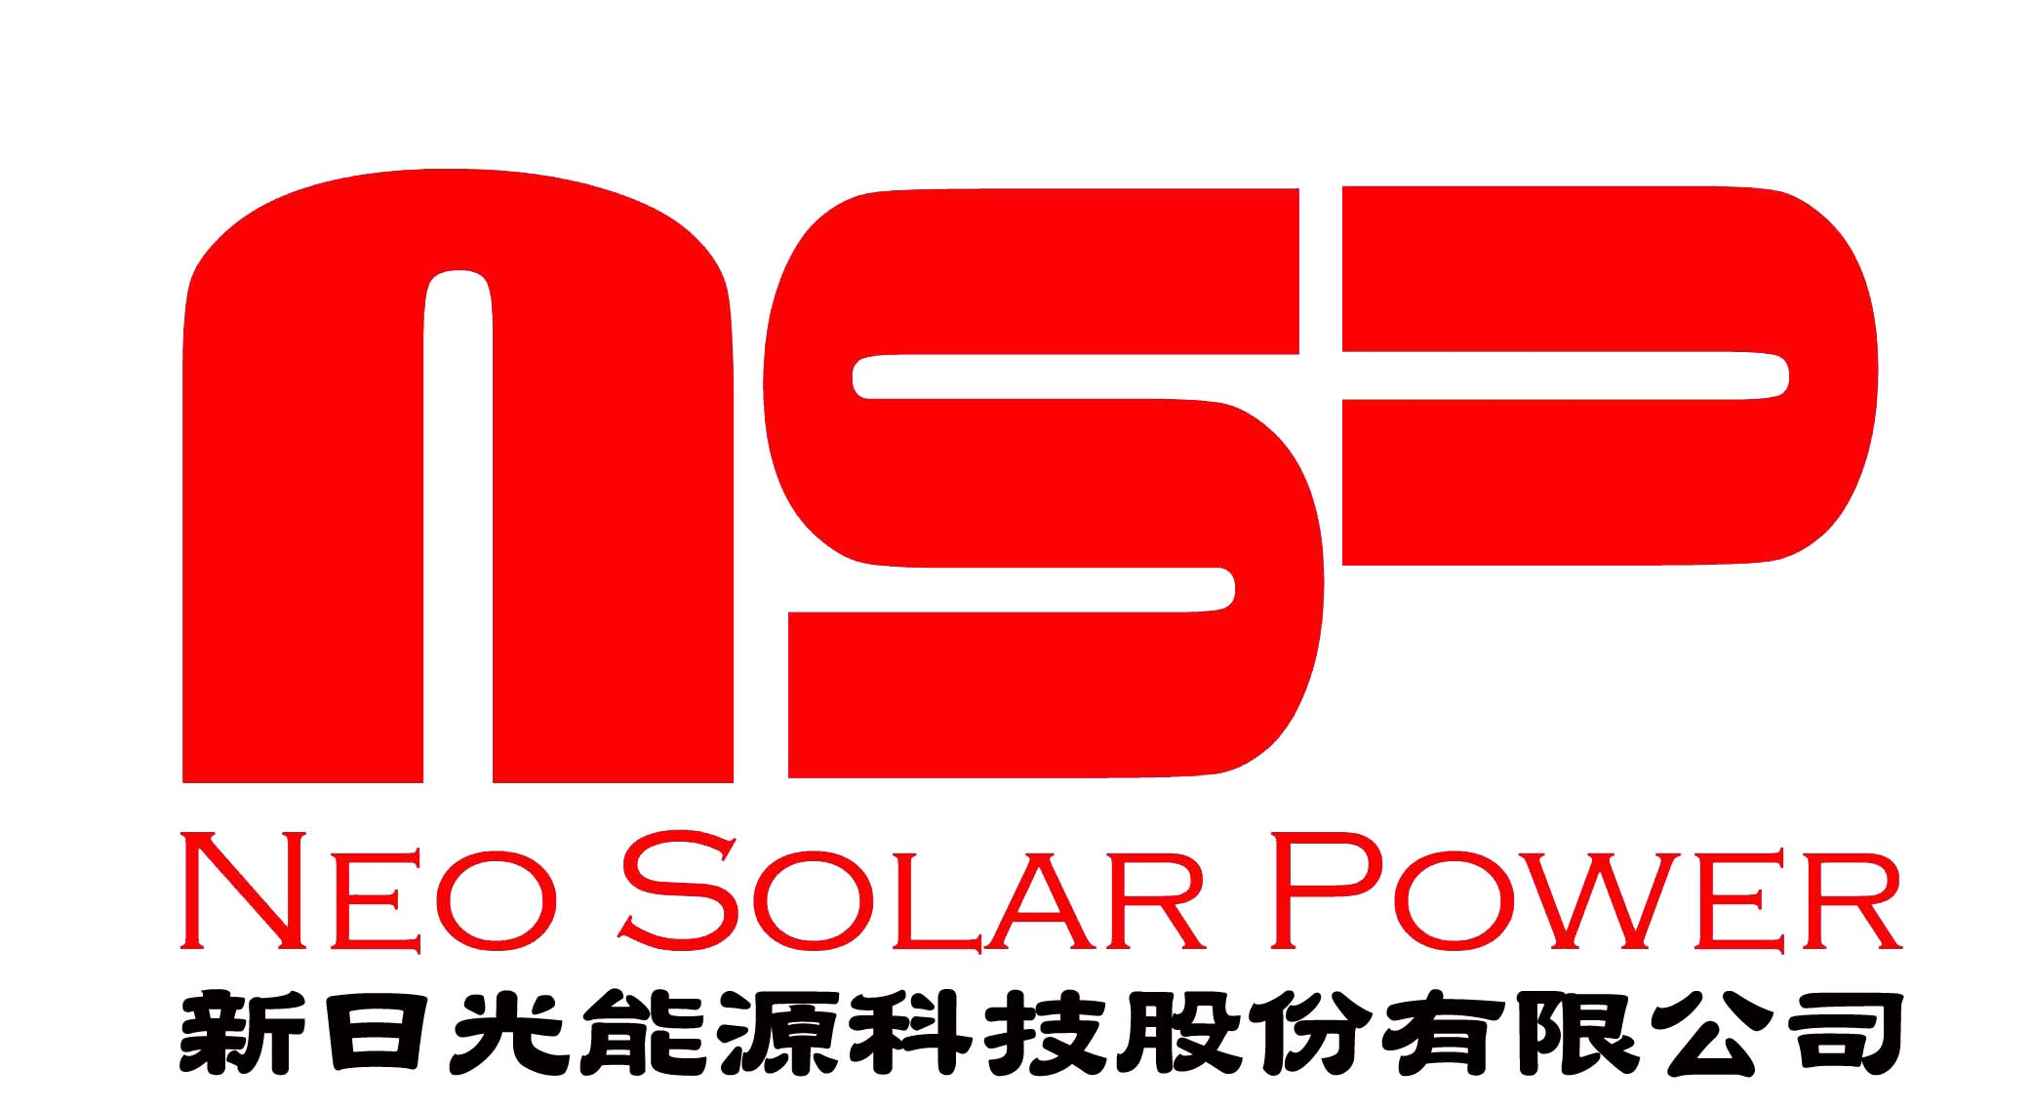

Comtec Solar and Neo Solar Power commence to supply
“Perfect Wafer” embedded in “Perfect Cell”

25 November 2009, Hong Kong and Hsinchu, Taiwan – Comtec Solar Systems Group Limited (“Comtec Solar” or the “Company, together with its subsidiaries the “Group”, 712 HK), a PRC-based leading manufacturer of monocrystalline solar wafers and Neo Solar Power Corporation (“NSP”, 3576 TT), a Taiwan-based leading solar cell manufacturer, have jointly developed and launched new products “Perfect Wafer” embedded in “Perfect Cell”. Solar modules made of “Perfect Cells” were demonstrated by NSP during the exhibition at Anaheim, USA in October 2009 and were highly appreciated by customers.

Comtec Solar pioneers to commercially launch the large sized “Perfect Wafer” to market. Traditionally 156mm mono-crystalline solar wafers are “pseudo-square” with the corners being cut off. The cut-off corners result in a smaller area from which solar cells and panels can capture sunlight. Comtec Solar’s “Perfect Wafer” enables cell and panel-makers to increase the active area and hence the amount of electricity generated.

NSP’s newly launched “Perfect Cell” using “Perfect Wafer” demonstrates panel-makers the ability to increase power density by more than 3% and has an average conversion efficiency of 17.8%. With NSP’s technology advancement, “Perfect Cell” offers extremely low light induced degradation with superior output that can easily exceed 250W.

Comtec Solar’s Chairman and CEO John Zhang said, “We are pleased to join hands with international leading solar cell manufacturers and support them in producing cells and panels of enhanced efficiency. The framework supply agreements are recognition of our efforts in strengthening R&D and enhancing production knowhow in producing high quality, large sized wafers that offer superior conversion efficiencies. We will continue our R&D effort in this regard to develop “Perfect Wafer” of even larger sizes to support the business growth of our customers.”

.NSP’s Chairman Quincy Lin said, “Including such a creative wafer maker into our diversified wafer base shall further enhance our capacity on volume delivery of the newly launched “Perfect Cell”. With its superior power generation performance and homogeneous dark appearance, NSP provides a “perfect choice” for system integrators to serve in both roof-top installations and BIPV application.”.

- End -

About Comtec Solar
Comtec Solar is a leading monocrystalline solar ingots and wafers manufacturer in the PRC. With its production base in Shanghai, the PRC, it focuses on the design, development, manufacturing and marketing of high-quality solar wafers. Comtec Solar, founded in 1999, is one of the first manufacturers in China to be able to mass produce 156mm x 156mm monocrystalline solar wafers with a thickness of approximately 170 microns. It has accumulated strong industry background from the manufacture of semiconductor ingots and wafers since 1999. Comtec Solar currently supplies most of its solar products to the leading solar cell/module manufacturers. Listed on Main Board of The SEHK on Oct .30, 2009, it is committed to enhancing product quality as well as developing new and innovative solar wafers. As it is well positioned to benefit from the growth of the solar PV industry, the Company aimed to broaden its customer base internationally. For more information please visit http://www.comtecsolar.com.

About Neo Solar Power Corporation (3576 TT) (NSP)
Founded in 2005, NSP specializes in manufacturing of high quality solar cells. Based in Hsinchu Taiwan, NSP currently has installed capacity of 210MW. Boosted by technology advancement, actual outputs are estimated at 230-250MW. Upon completion of equipment installation of its new FAB 2 at Hsinchu Science Park, total installed capacity shall reach 700MW and actual outputs shall reach 800MW or more. Seasoned through a long history in the semiconductor and solar industry, NSP produces cells with high efficiency and minimum power loss. Leveraging core competence on quality, technology and technical services, NSP aims to become a global leader in the photovoltaic industry and to make solar energy a competitive energy source. For more information on NSP, please visit http://www.neosolarpower.com/

For further information, please contact:
Contact of Comtec Solar
Investor Relations Department
Ms. Laura Liu Tel: 86-21-68043040, 13764312946 Email: laura_liu@comtecsolar.com
Ms. Jean Wang Tel: 86-21-68043040, 15901865611 Email: Jean_wang@comtecsolar.com

Contact of NSP:
Meg Tsai, Deputy Department Manager of Investor Relations & Shareholders’ Services
Tel: 886-3-578-0011#20601
E-mail: meg.tsai@neosolarpower.com

